Sandomir and Rasia Kolbe
1.Sandomir and Rasia Kolbe, ages fifty eight and fifty seven respectively, and their three grown children, recently attended Sandomir’s father’s funeral in Poland. They realized that they did not know the effect of federal estate tax on their own estate, nor did they have any legal documentation supporting end-of-life medical or financial decisions. So, upon returning home, Rasia called her mother for a recommendation regarding estate planning help. Rasia’s mother suggested an attorney for the legal documents and her own financial planner for other estate planning needs. For the purposes of this problem, assume all family members are citizens of the United States. Financial information for the Kolbe family follows:

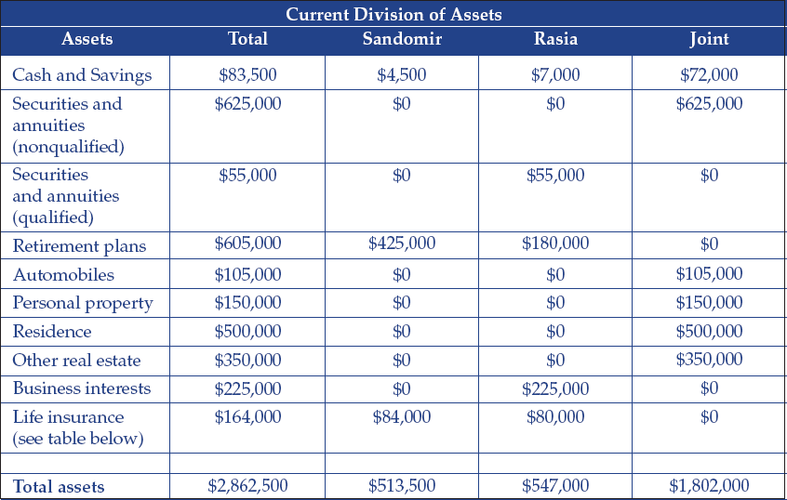
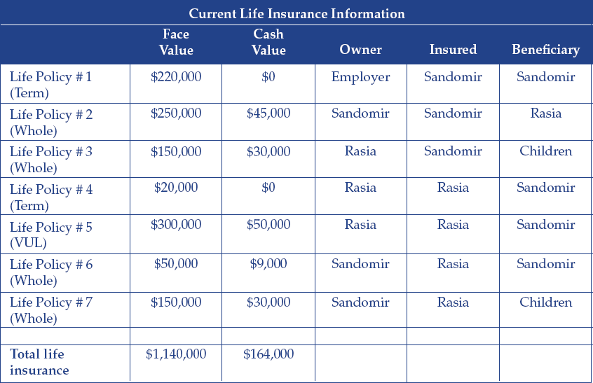

Based on the Kolbes’ financial information, the lawyer and the financial planner jointly made the following recommendations:
Recommendation 1: Establish testamentary trusts for both Sandomir and Rasia.
Recommendation 2: Retitle assets in preparation of funding trusts.
Recommendation 3: Transfer life insurance ownership to the three children.
To assist the Kolbes with their estate planning, answer the following questions.
a.What type of trust(s) might be recommended in keeping with the clients’ desires of minimizing estate taxes, maximizing privacy, and easing asset ownership transfers?
b.How might the assets be retitled to ensure that all trusts can be adequately funded?
c.What are some of the challenges associated with transferring ownership of the insurance policies to the children? Describe some of the problems with the current life insurance designations. What other strategies can also be considered to alleviate any potential estate, gift, or income tax issues?
d.Besides completing wills and trust documents, what other legal documents should the Kolbes consider?

Jane and John Williams
2.Assume the following estate planning information for Jane and her spouse John.
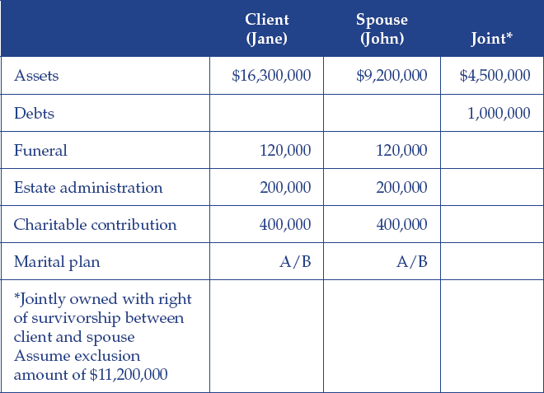

a.If Jane were to pass away first, what is her tax liability before the marital deduction?
b.If John were to pass away first, what is his tax liability before the marital deduction?
c.Using the portable estate exemption, how much of their combined estate is taxable today?
d.If Jane and John fail to take advantage of the portable estate exemption by forgetting to file IRS Form 706 at the death of the first spouse, will there be a tax liability this year, assuming the second spouse also passes shortly thereafter? Describe an estate planning strategy that can be used to minimize any estate tax liability in this situation.
Brenda Chatterjee
3.Brenda Chatterjee is wealthy, single, and generous. During the previous year she made the following gifts:
•Gift of stock to the local art museum (a 501(c)(3) nonprofit organization): $245,000
•College tuition payment for niece: $29,000 made directly to the institution
•Medical bills for elderly neighbor: $18,000 paid directly to the hospital
•Home down payment gift to daughter: $30,000 paid directly to the mortgage lender
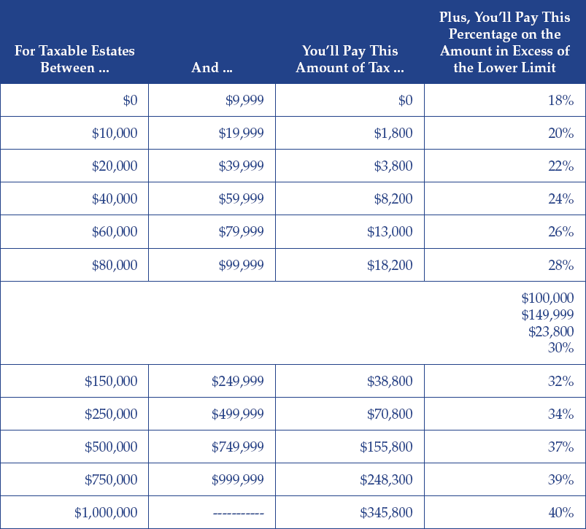
•Cash gift to son: $17,000
•Use the gift tax rates shown below as a guide to answer the following questions:
a.What is the total amount of taxable gifts in 2018?
b.What is Brenda’s gift tax liability in 2018?
c.Assuming a unified credit of $4,425,800, what alternative does Brenda have in terms of paying the gift tax liability?

Malek and Nelda Goetz
4.Malek and Nelda Goetz live in Nevada. They are working with you to deal with several estate planning questions and concerns. Use your estate planning skills to answer the following questions:
a.Nelda read that it is a good idea to have a power of attorney in place to help deal with incapacitation issues. She is worried, however, that providing someone power over the family’s financial situation now could lead to unnecessary problems and confusion. What type of POA can Malek and Nelda establish that will address her worries? What needs to occur to trigger this type of POA?
b.Malek and Nelda were married in Nevada. In fact, they have lived their entire life in Nevada. If Malek were to pass away, with the family home valued at $500,000 at Malek’s death, what will be Nelda’s new basis in the property? Assume the basis in the home is $100,000.
c.Avoiding probate is a primary concern for Malek. Which of the following assets will be subject to probate?
•A personal residence owned JTWROS with a child.
•Life insurance proceeds paid to a non-insured beneficiary.
•Property titled as tenants in common.
•Brokerage account.
d.Malek would like to reduce the value of the family gross estate by transferring ownership of the family’s second home to his daughter; however, he is worried that he and Nelda may need to live in the house in the event they sell their primary residence (the primary residence is under contract for sale). Malek and Nelda should consider establishing what type of trust to deal with this potentiality?
e.Nelda owns a small business with three other individuals. The business is growing and profitable. Nelda would like to establish a buy-sell agreement to ensure business continuity. What type of agreement should she establish, with her business partners, if she hope that each business owner will purchase life insurance on the life of each other business owner?
f.At what age can Malek’s son elect to access assets held in a Section 2503(b) trust (the son is named as the beneficiary)?

